Ref Scheduler Web Application

Logging In:
Go to https://www.ssssol.com/RefNet/RN_Login.aspx and log in.
We are Chapter Code: RS1_12
Your username and password have been (or will be) sent to you…
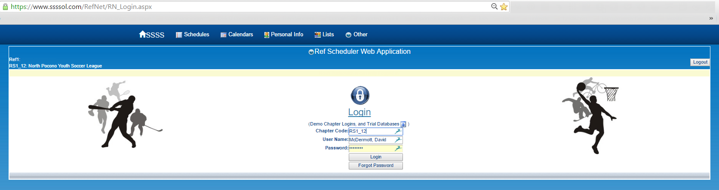
Initial Screen:
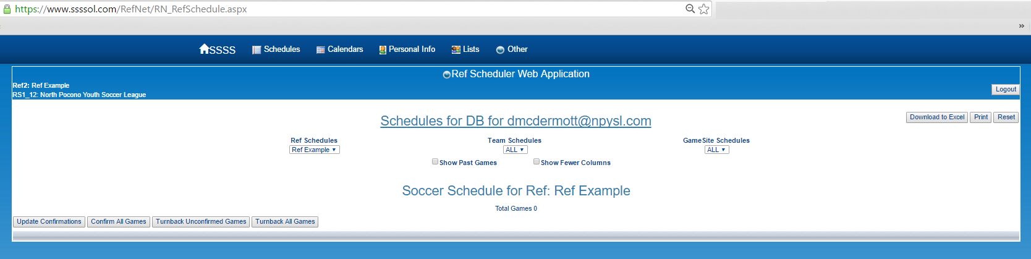
IF you have a game assigned:
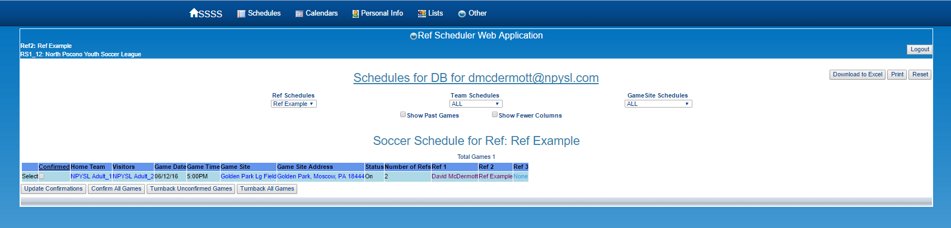

Update Personal Info
You can also change your personal info: Click “Personal Info”
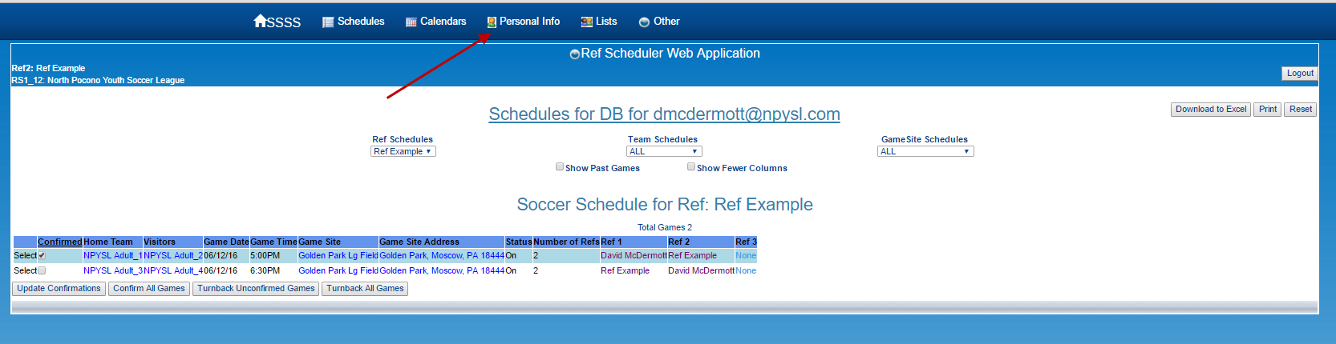

Update your info as appropriate: Please keep it updated!!!
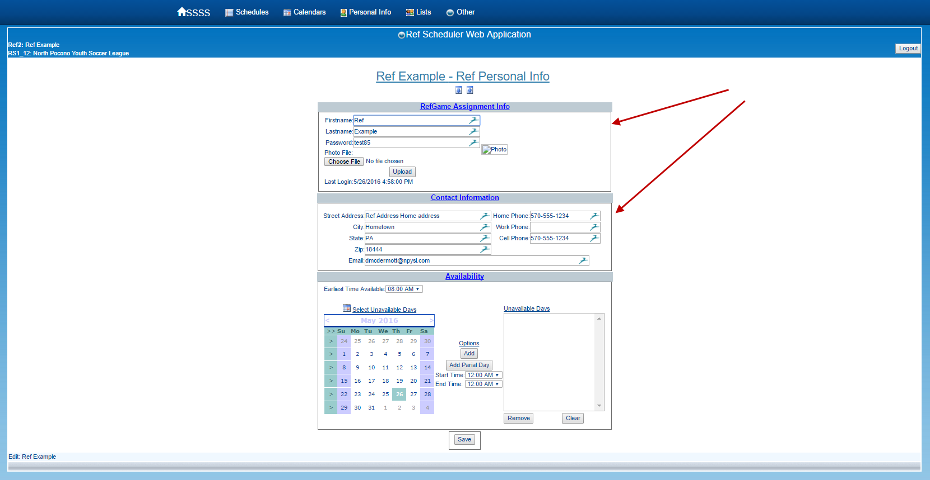

Make sure you click save at the bottom of the page:
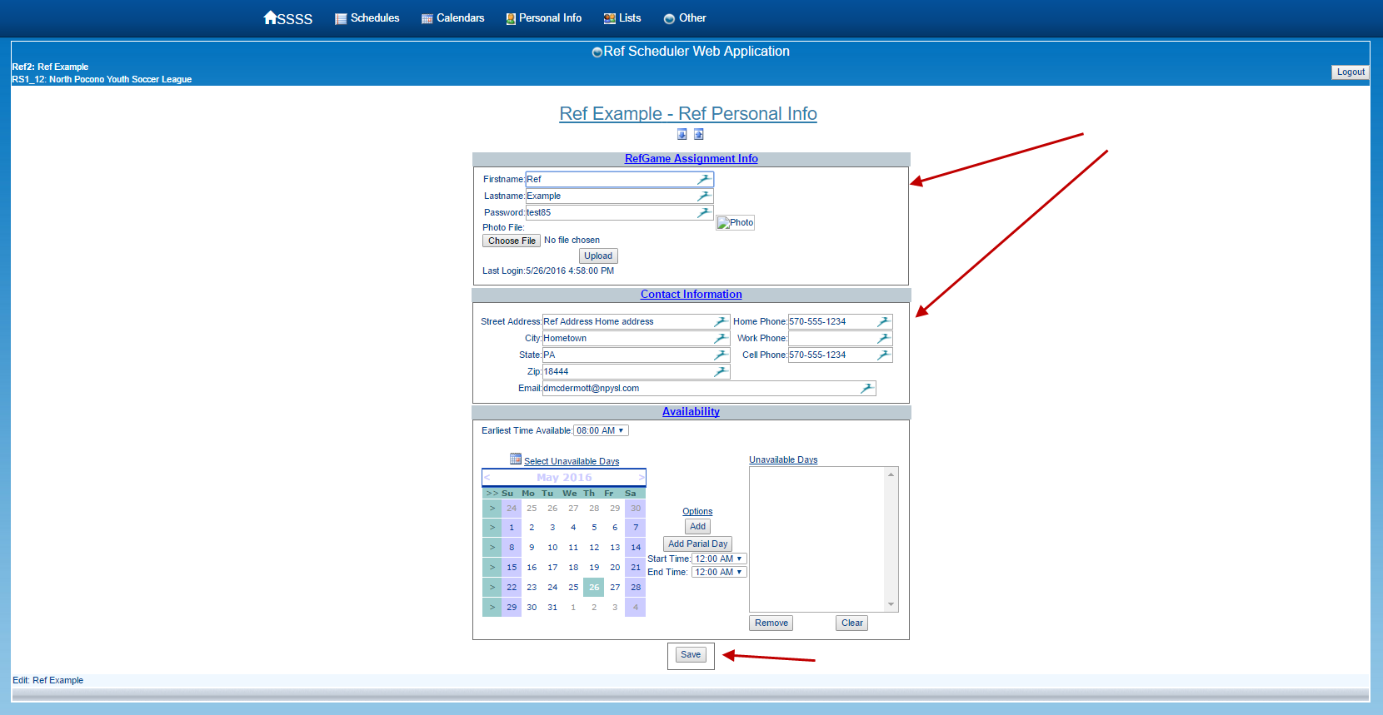

Availability / NOT Available
To enter your availability (actually your lack of availability), so you aren’t scheduled for games that you aren’t available:
Click Personal Info:
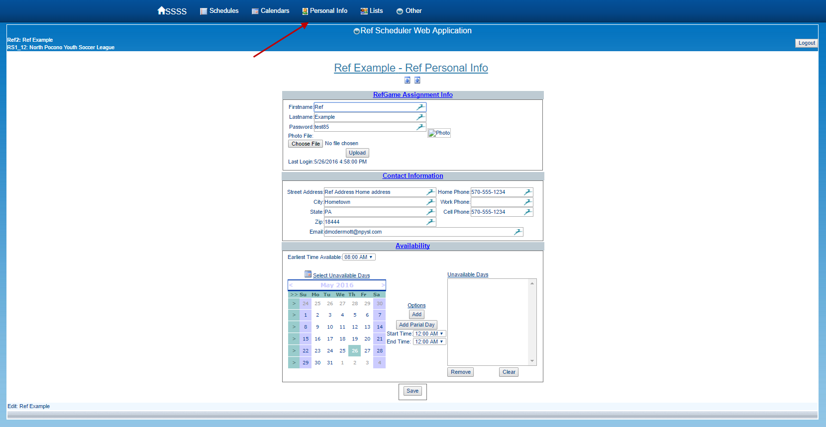

Go down to the Availability section. Click the date you are UNAVAILABLE. If it’s the entire day, Click Add under Options.
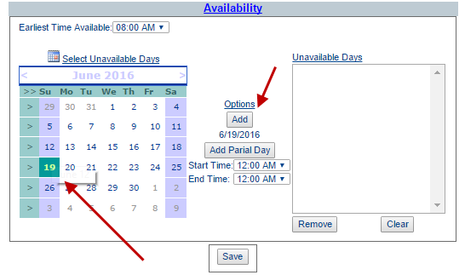

It will show in the right frame:
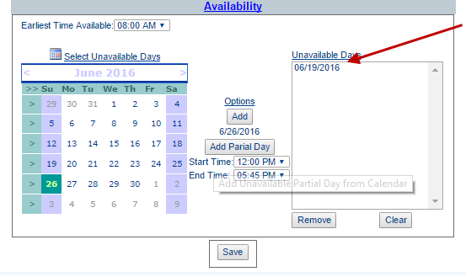

If you are unavailable for only part of the day, Click the date, then adjust the time you aren’t available
And click “Add Parial Day” (yes, it should say Partial…)

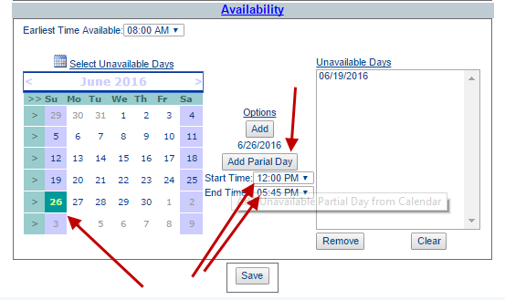

It will show in the right frame:
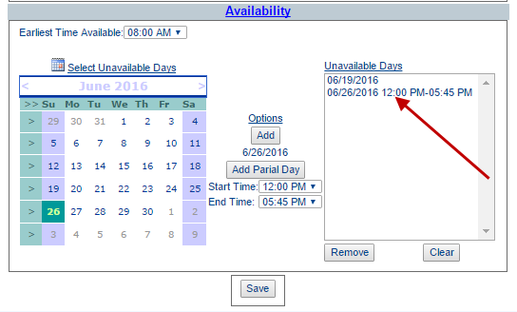

Scheduling:
To see your schedule in a calendar format, click Calendars:
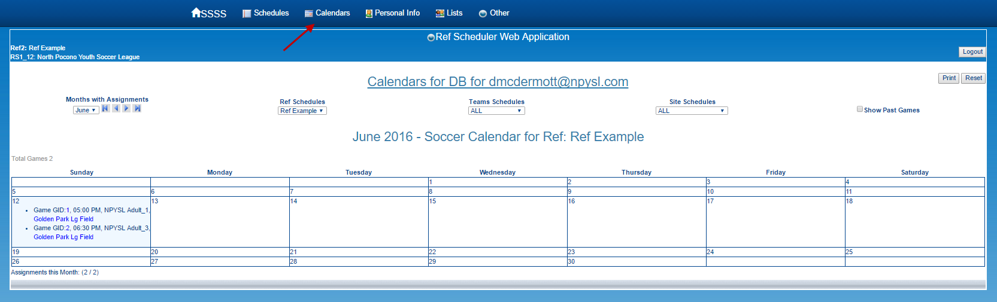

To see your schedule in a list, click Schedules:
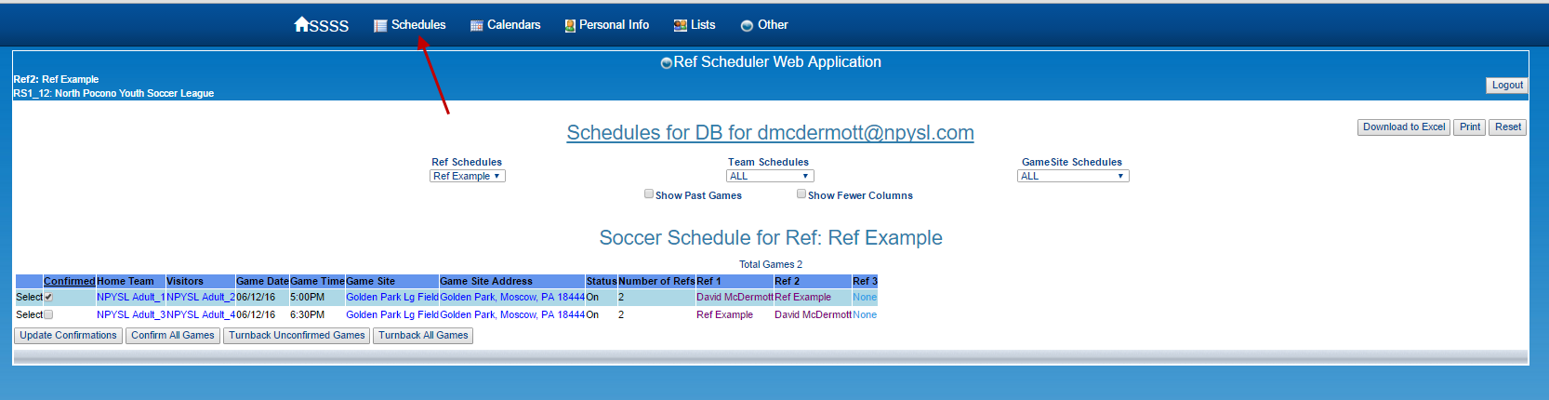

Confirm Games:
To Confirm you will ref a game:
You can check the confirmed box and then “Update Confirmation”, or just click “Confirm All games”.
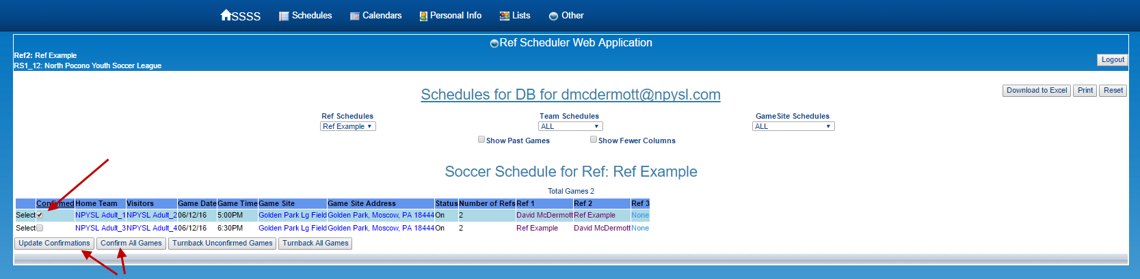

Reject a Game: “Turnback”
If you can’t do the game, reject or “Turnback” the game by first Unchecking the confirmed box if it is already confirmed, and then click “Turnback Unconfirmed Games” or “Turnback All Games”…
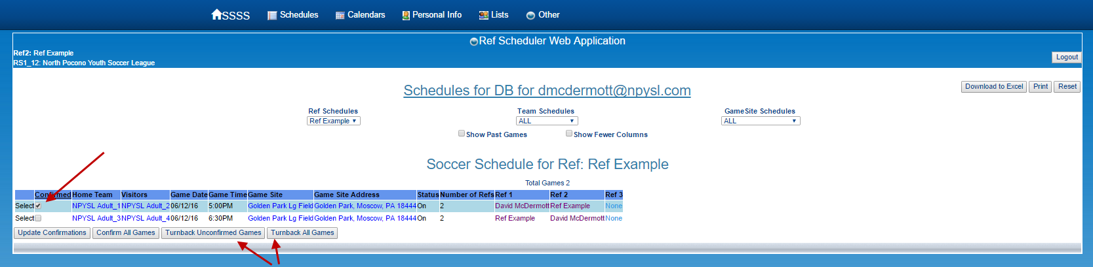

Then Confirm you want to “Turnback the assignment”:
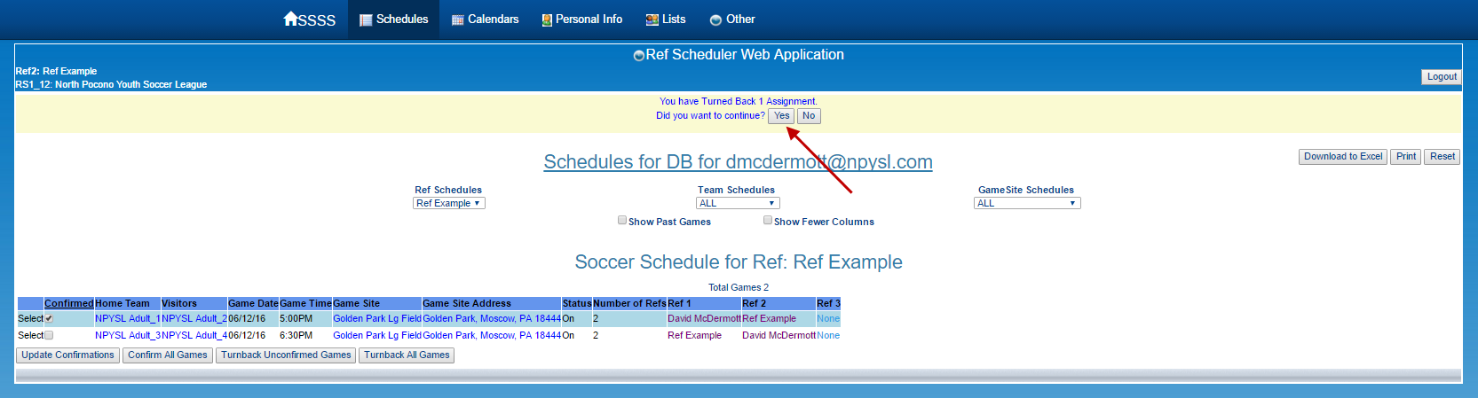

It will confirm you have “Turned Back” the assignment:
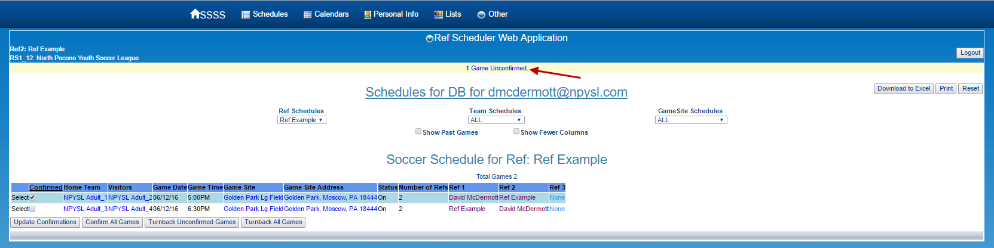

Confirmation
For each Confirmation or Cancelation (“Turnback”), you are supposed to receive an email confirmation.
*** THIS IS NOT QUITE WORKING YET – I will be sending them Manually for now) ***

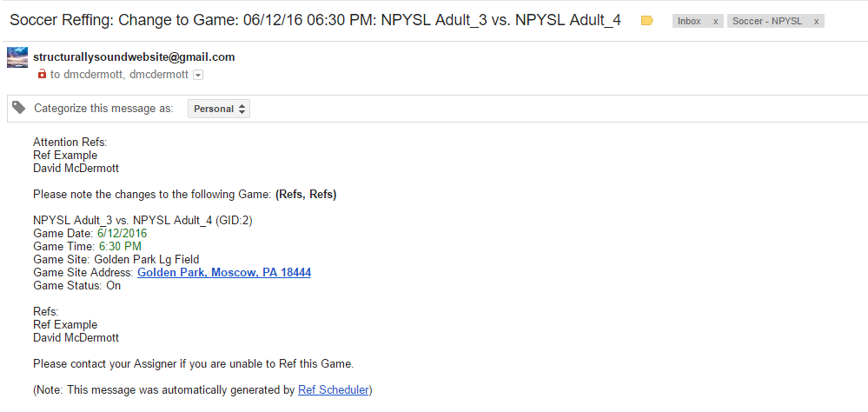

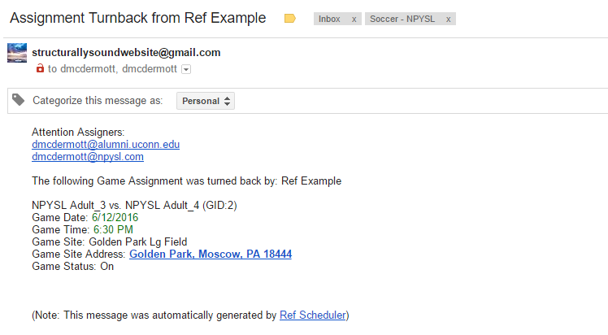

Announcements
Please be sure to check the Announcement section as well - though I will email most information…
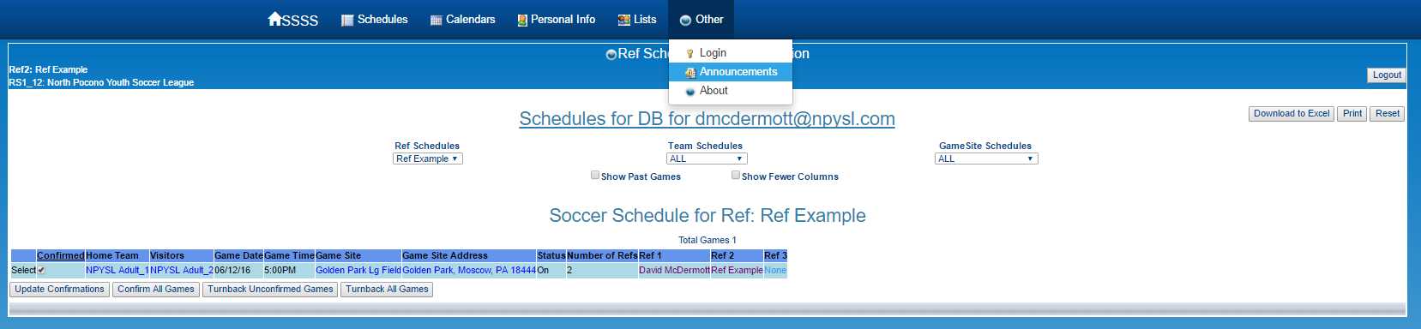

Please contact Dave McDermott, NPYSL, Referee Coordinator at dmcdermott@npysl.com or 570-433-8501, with any questions.

